**Daily Scrum or Standup Meeting**

Team name: Group 8_________________________

Scrum Master: Cole_______________________

Date: 3-28_______________________________

|  |  |  |  |
| --- | --- | --- | --- |
| **Team Member** | **What did you do since the last scrum?** | **What do you plan to do before the next scrum?** | **What obstacles do you have?** |
| Jeremy | Worked on refactoring lot schema | Finish refactor | Time |
| Austin | N/A | N/A | Time |
| Logan | Worked on adding auth tokens, and on adding a balance field to user | Continue working on all that | Time |
| Cole | N/A | N/A | Time |
|  |  |  |  |

# Burndown

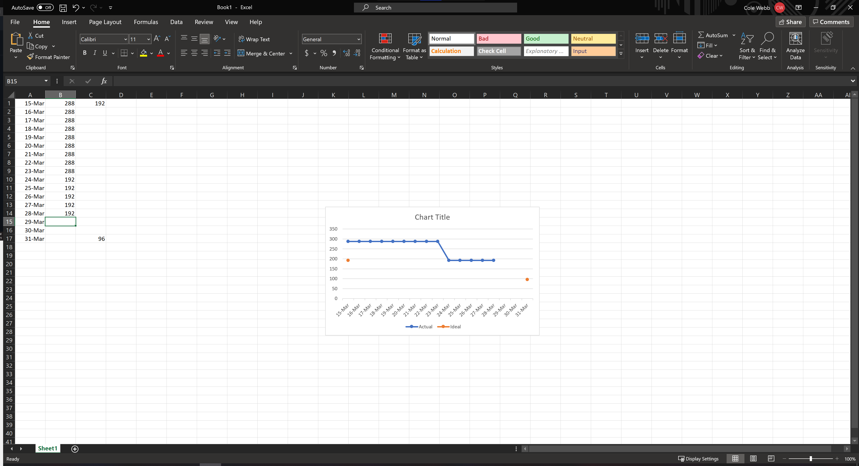

# Screenshot of you project board

